VISION CRAFT
A Browser-Based Image Processing Project
PROJECT REPORT
Submitted by: Chitranshi Gupta and Arpita Samantaray
Department / Class: IPA 11
Institution: KIIT
Academic Year: 2026-2027

Abstract
Vision Craft is a browser-based image-processing application designed to make fundamental digital image processing techniques easy to explore through an interactive interface. Users can load a JPG or PNG photograph and apply grayscale conversion, negative transformation, Sobel edge detection, histogram visualization, Gaussian blur, sharpening, thresholding, and sepia tone. The processed result is displayed in a central light-table workspace, with controls for adjusting the threshold, resetting the current frame, and saving the output. The project combines practical visual experimentation with concise labels that connect each operation to its underlying concept. Its main purpose is educational: to help users observe how image transformations alter pixel intensities, edges, texture, and colour. The implementation details and performance should be verified against the project’s source code.

1. Aim
To design and develop an interactive web application that demonstrates fundamental digital image processing techniques by allowing users to load an image, apply different transformations, inspect the results, and save the processed output.

2. Objectives
- Provide a simple interface for loading JPG and PNG images.
- Implement and demonstrate common image-processing operations.
- Display the processed image immediately so users can compare visual effects.
- Visualize grayscale intensity distribution using a histogram.
- Allow the threshold value to be adjusted for binary image generation.
- Provide reset and save controls to support repeated experimentation.
- Perform image processing locally in the browser, as indicated by the interface.

3. Software and Hardware Requirements

Software requirements
- Operating system: Windows, macOS, or Linux.
- Web browser: a modern browser such as Google Chrome, Microsoft Edge, or Firefox.
- Editor: Visual Studio Code or any text editor for HTML, CSS, and JavaScript.
- Local development server: for example, VS Code Live Server (the screenshots show a local address at 127.0.0.1:5500).
- Core web technologies: HTML for structure, CSS for layout and styling, and JavaScript for image handling and processing.
- No separate image-processing installation is required if the implementation uses browser APIs and JavaScript.

Hardware requirements
- A desktop or laptop capable of running a modern web browser.
- Keyboard and mouse or touchpad.
- Sufficient memory for the browser and the image being processed.
- An internet connection is not inherently required for local processing after the project files are available, provided no external libraries or services are loaded.

4. Theory

4.1 Digital images and pixels
A digital image is represented as a grid of pixels. In a colour image, each pixel commonly contains red, green, and blue (RGB) intensity values, usually in the range 0–255 per channel. Image processing modifies these values or analyzes how they vary across the image.

4.2 Grayscale conversion
Grayscale conversion maps each colour pixel to a single intensity value. A common luminance-weighted formula is Y = 0.299R + 0.587G + 0.114B. The result retains brightness structure while removing colour information.

4.3 Negative transformation
A negative reverses intensity values. For an 8-bit channel, the transformation is output = 255 − input. Dark areas become light and light areas become dark; the same idea can be applied to each RGB channel.

4.4 Edge detection (Sobel)
Edges often correspond to sharp changes in intensity. The Sobel operator applies horizontal and vertical gradient kernels to estimate changes in brightness. The gradient magnitude can be calculated as G = √(Gx² + Gy²). Stronger responses indicate likely edges, although noise and fine texture can also produce responses.

4.5 Histogram
A grayscale histogram counts how many pixels occur at each intensity level from 0 to 255. It helps show whether an image is predominantly dark, bright, or spread across a broad range of intensities. A histogram describes the distribution of values, not where those pixels occur spatially.

4.6 Gaussian blur
Gaussian blur smooths an image by replacing each pixel with a weighted average of neighbouring pixels. Nearby pixels receive larger weights according to a Gaussian-shaped kernel. This reduces fine detail and noise but can also soften edges.

4.7 Sharpening
Sharpening increases local contrast, often by using an unsharp-mask or convolution method. A common approach subtracts a blurred version from the original to estimate fine detail, then adds some of that detail back. Excessive sharpening can amplify noise and create halos.

4.8 Thresholding
Thresholding converts an intensity image into a binary image. For a threshold T, pixels above T are set to white and pixels at or below T are set to black (or vice versa, depending on implementation). The threshold slider in Vision Craft allows the user to explore how the selected cutoff changes the result.

4.9 Sepia transformation
Sepia applies a colour transformation that shifts an image toward warm brown and yellow tones. It is commonly used to create a vintage photographic appearance.

5. What the Project Does
The user selects or drops a JPG/PNG image into the “Load Negative” area. After loading, the image appears in the central light-table workspace. The user chooses an operation from the left panel, and the workspace displays the transformed image. The screenshots demonstrate grayscale, negative, edge detection, histogram, blur, sharpen, threshold, and sepia. The interface also shows the output dimensions and operation name, offers a threshold slider for binary conversion, and includes a reset-frame control and a save-frame action.

6. Working Methodology
1. Load an image from the local device.
2. Read the image into the browser and draw or process it using browser-side image APIs (the exact implementation depends on the source code).
3. Choose an image-processing operation from the operation panel.
4. Apply the selected pixel transformation or calculate the histogram.
5. Render the result in the light-table area.
6. Adjust the threshold if thresholding is selected, or choose another operation to explore a different result.
7. Reset the frame to return to the original image, or save the processed output.

7. How Vision Craft Is Different
- It combines several classical image-processing operations in one interface rather than demonstrating only one filter.
- The operation list explains the technique briefly (for example, “Sobel gradient magnitude” or “Gaussian 5×5 kernel”), helping connect the interface to the underlying theory.
- It presents the output in a dedicated light-table workspace, giving the experience a visual laboratory / darkroom theme.
- The histogram is included alongside visual filters, so users can inspect image intensity distribution as well as transform the image.
- The threshold slider makes at least one processing parameter adjustable, encouraging experimentation instead of showing only a fixed result.
- The interface indicates that processing is performed on-device, which can reduce the need to upload photographs to a remote server if the implementation truly keeps processing local.
These differences are based on the supplied screenshots. A definitive comparison with other products would require testing their features, performance, privacy behaviour, and supported formats.
The table below summarises the two team members’ roles. Please adjust the descriptions if the division of work differed from the contributions actually made.

7B. Team Member Contribution
Vision Craft’s novelty lies in bringing multiple foundational image-processing operations into a single, browser-based visual workspace with a consistent interface. Rather than presenting isolated code outputs, it lets a user load a personal image, choose a technique, and immediately observe the transformation. The inclusion of a grayscale histogram alongside visual filters adds a simple analytical tool, while the adjustable threshold control supports experimentation with how pixel-intensity cutoffs affect a binary image. The darkroom-inspired “light table” design and short technique labels make the tool feel like an interactive image-processing lab. These are practical and educational differentiators; claims of being the first or uniquely advanced tool are not made without a formal comparison.

7A. Novelty / Unique Features
Team member | Role / responsibility | Contribution details
Chitranshi Gupta (24155463) | Interface design and project integration | Contributed to the Vision Craft interface, page layout, operation-selection workflow, and integration of the image-processing workspace.
Arpita Samantray (24155912) | Image-processing features and testing/documentation | Contributed to implementing or validating image-processing operations, checking visual outputs, and documenting the project and its results.

8. Advantages
- Easy to use: operations are selected through visible controls.
- Interactive learning: users can immediately see how a filter changes an image.
- Multiple techniques in one place: supports a compact practical demonstration.
- Histogram support provides a basic analytical view, not just a visual effect.
- Local browser processing can improve privacy and reduce server dependency.
- Threshold adjustment supports experimentation with different cutoffs.
- Reset and save controls make it easier to repeat tests and keep results.

9. Disadvantages and Limitations
- The available operations are classical filters; the interface does not demonstrate advanced segmentation, object recognition, or AI-based enhancement.
- A fixed threshold can perform poorly when lighting varies across the image; adaptive thresholding may be needed for some tasks.
- Sobel edge detection can highlight texture and noise as well as meaningful object boundaries.
- Blur reduces detail, while sharpening can exaggerate noise or create visual artefacts.
- The screenshots show one image and do not establish performance on very large images or on mobile devices.
- The interface appears to focus on JPG and PNG; support for other formats is not demonstrated.
- The report is based on screenshots, so details such as exact algorithms, error handling, accessibility, and browser compatibility should be verified against the source code.

10. Applications
- Teaching introductory digital image processing concepts.
- Demonstrating intensity transformations and convolution-based filters.
- Basic photo experimentation and visual-effects exploration.
- Preliminary inspection of image brightness distribution.
- A starting point for more advanced computer-vision projects.

11. Future Scope
- Add side-by-side original and processed image comparison.
- Provide sliders for blur radius, sharpening strength, and edge sensitivity.
- Add adaptive thresholding, brightness/contrast adjustment, and colour-channel views.
- Support undo/redo and sequential filter pipelines.
- Add batch processing and export options for multiple formats.
- Improve accessibility, responsive mobile layout, and keyboard navigation.
- Add a short explanation and mathematical formula for each selected operation.
- Test image sizes, performance, browser compatibility, and local-processing privacy claims.

12. Conclusion
Vision Craft provides a clear, interactive demonstration of foundational digital image processing. By combining colour-to-grayscale conversion, negative transformation, edge detection, histogram visualization, blur, sharpening, thresholding, and sepia in a single browser interface, it helps users connect theoretical operations with their visible effects. Its strongest value is as an educational image-processing laboratory. Further work could improve parameter control, comparisons, accessibility, and support for more advanced computer-vision techniques.

References / Learning Resources
- R. C. Gonzalez and R. E. Woods, Digital Image Processing, Pearson.
- MDN Web Docs: Canvas API and HTML image handling — https://developer.mozilla.org/
- OpenCV documentation: Image Processing — https://docs.opencv.org/
- The specific implementation should be documented from the project's HTML, CSS, and JavaScript source files.

Appendix A: Project Screenshots
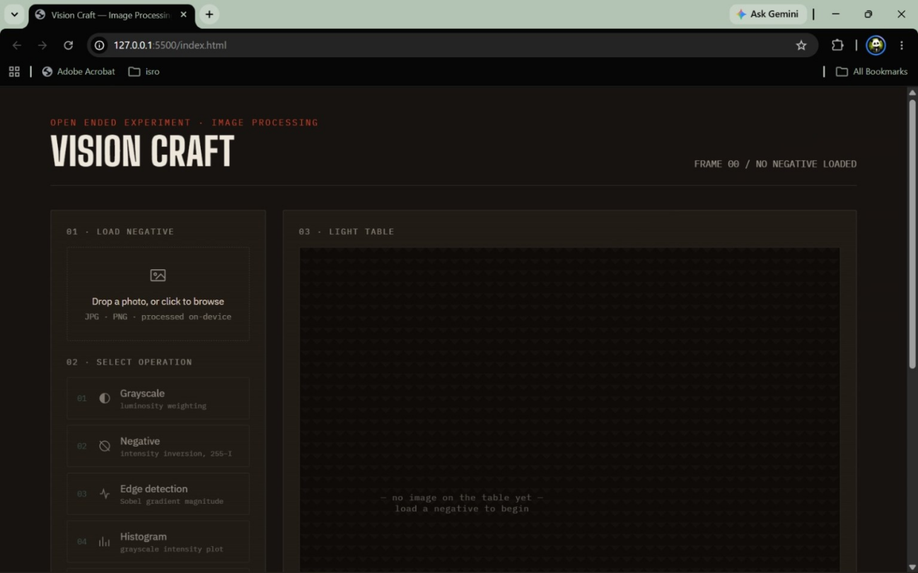
Figure 1. Vision Craft interface before an image is loaded.
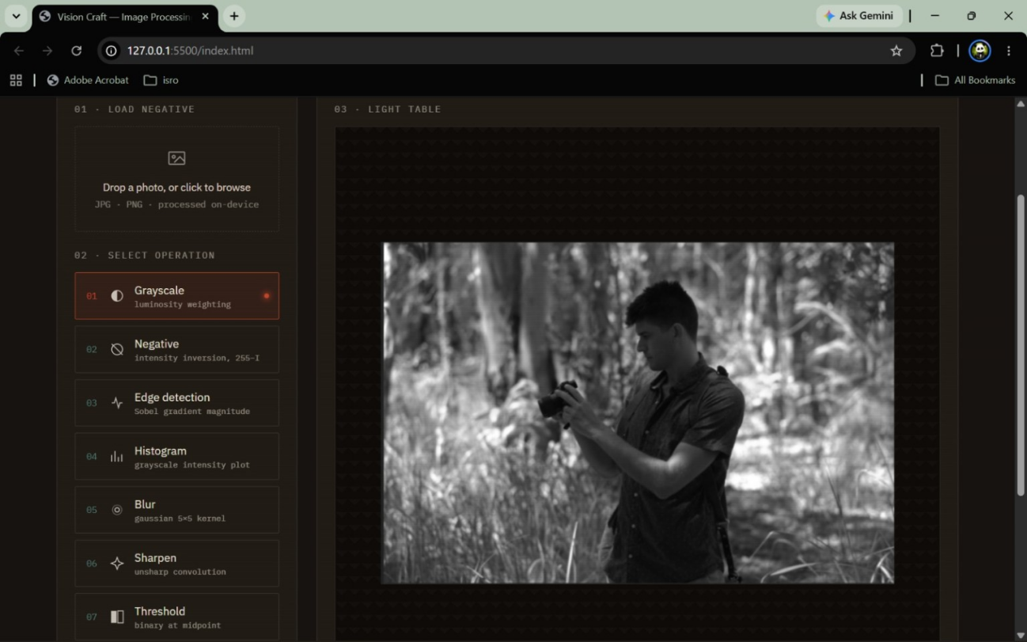
Figure 2. Grayscale operation converts the image into shades of gray.
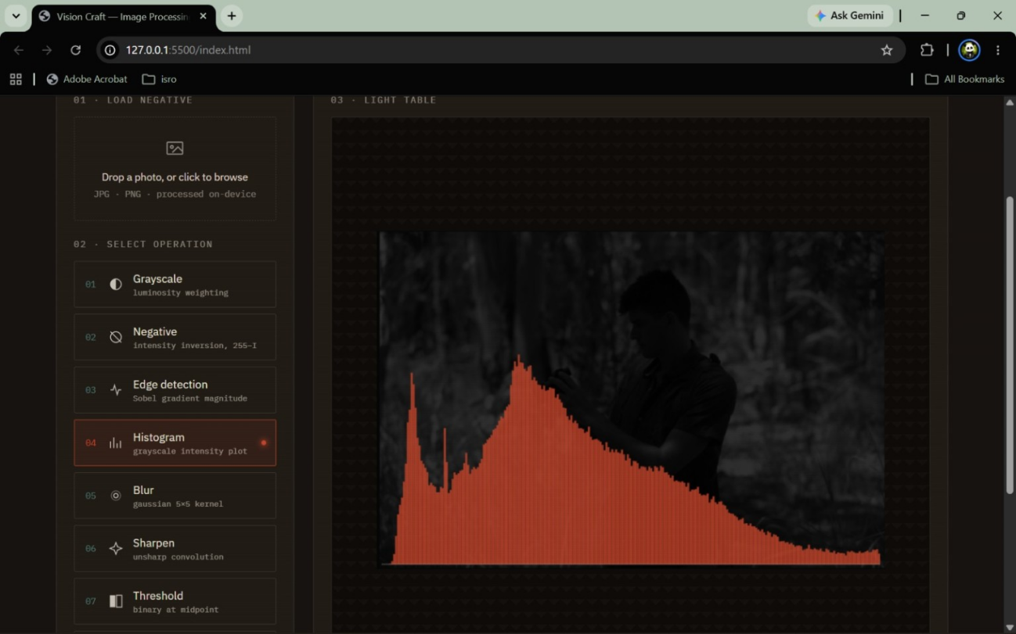
Figure 3. Histogram operation displays the distribution of grayscale intensities.
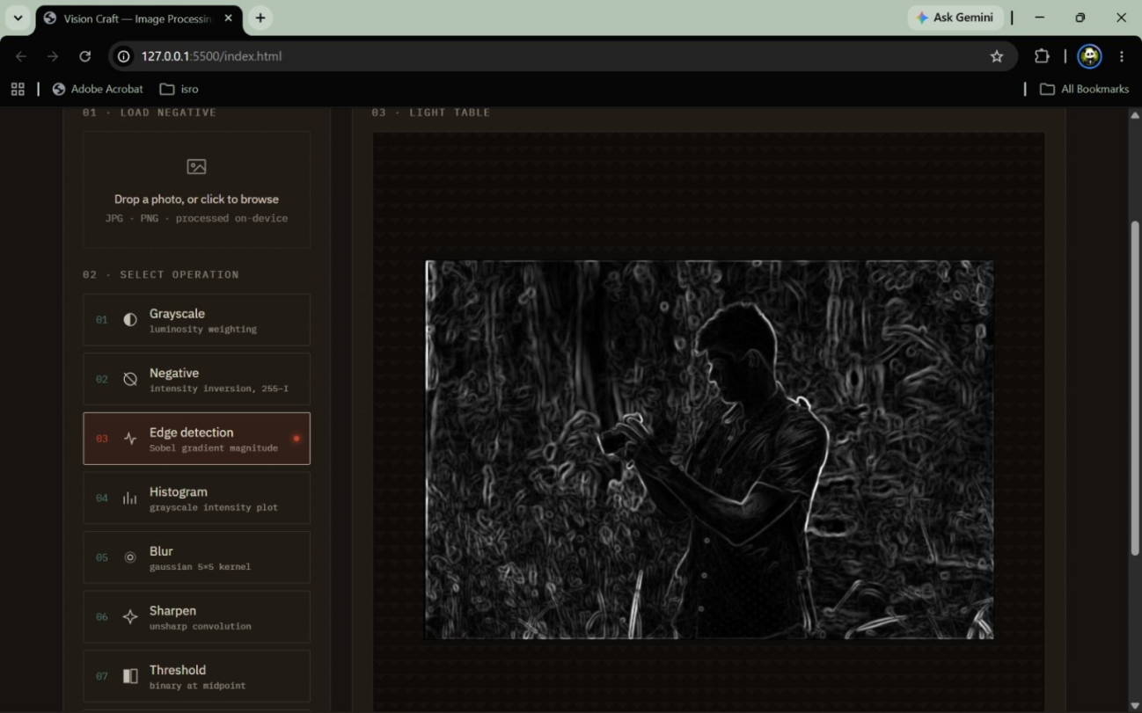
Figure 4. Sobel edge detection highlights boundaries and texture.
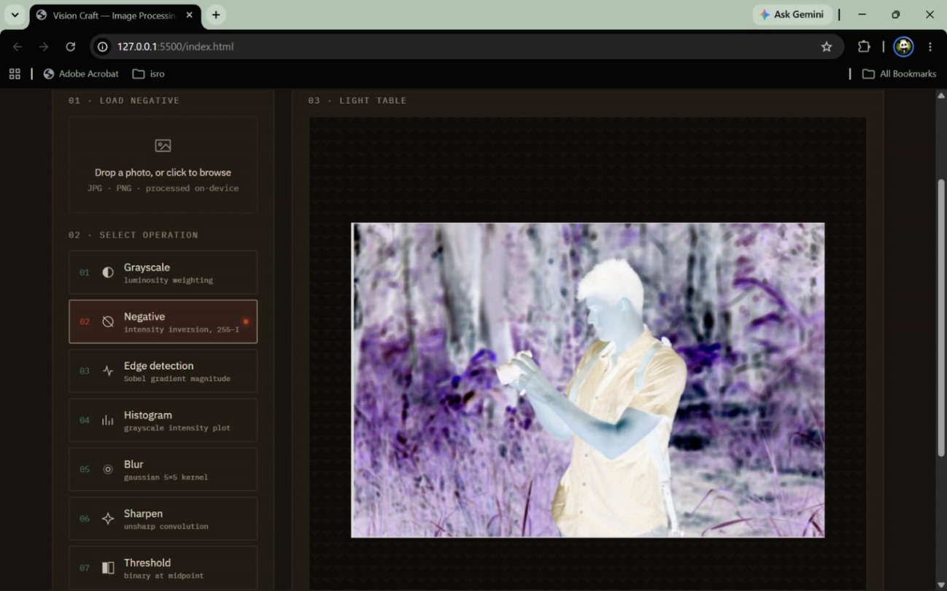
Figure 5. Negative operation inverts image intensity values.
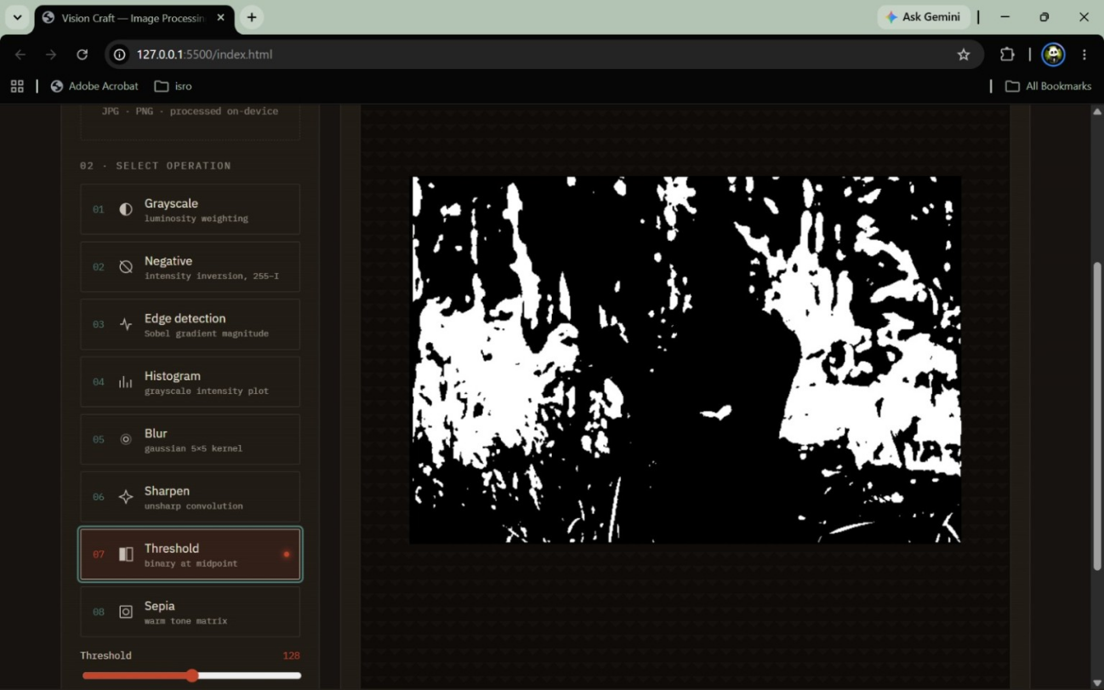
Figure 6. Thresholding produces a binary black-and-white image.
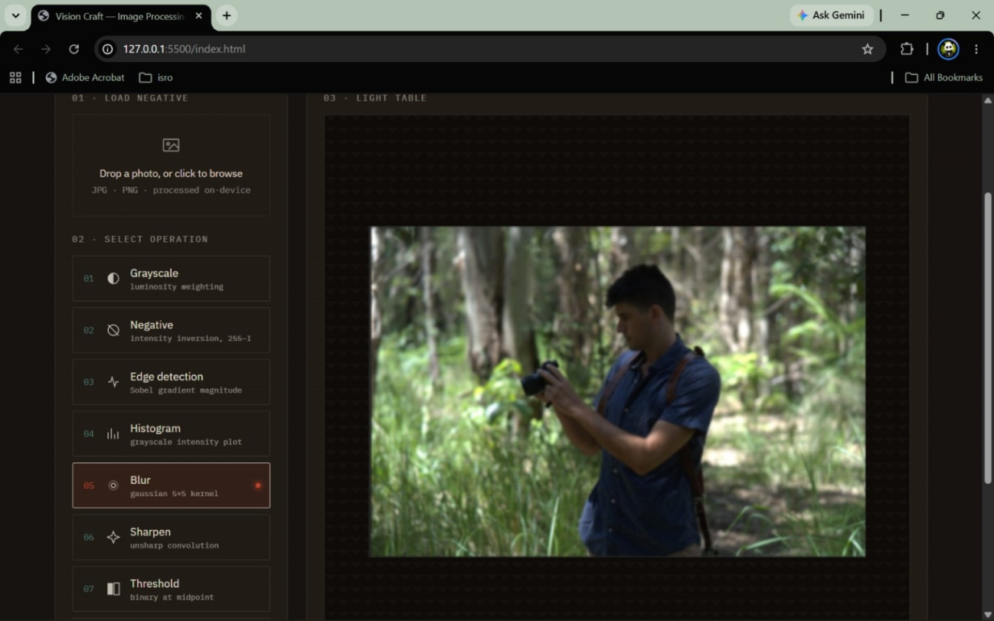
Figure 7. Blur operation smooths details using a Gaussian kernel.
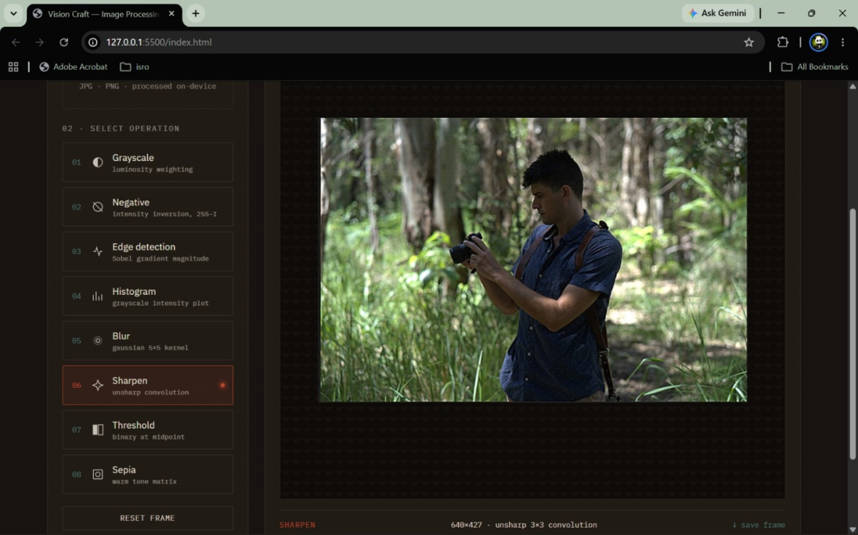
Figure 8. Sepia applies a warm, vintage-style tone.
VISION CRAFT
A Browser-Based Image Processing Application
PROJECT REPORT
An interactive demonstration of fundamental digital image processing techniques
Submitted by | Chitranshi Gupta (24155463) and Arpita Samantaray (24155912)
Team members | Chitranshi Gupta (24155463); Arpita Samantaray (24155912)
Programme / Department | B.Tech, Computer Science & Engineering (AI & ML)
Institution | Kalinga Institute of Industrial Technology (KIIT), Bhubaneswar
Academic year | 2026–2027

Submitted in partial fulfillment of academic project requirements

